Group 4 Project Final Report

Javeria Ali – 24110065
Muhammad Ahmed Ehtisham – 24110167
Muhammad Faseeh Bilal – 24110341
Muhammad Ibrahim Sani – 23110230
Rahima Aizaz Khan – 24110059

SDSB, Lahore University of Management Sciences
DISC 322: Optimization Methods in Management
Professor Kamran Rashid
December 08, 2022

Table of Contents

Group 4 Project Final Report 1
Introduction 3
Problem Statement 3
Assumptions 4
Variables 5
Formulation of LP 6
Objective Function 6
Constraints 7
Sensitivity Analysis 10
Decision Variables 10
Constraint Table 13
Recommendation 15
Scenario 17

Introduction
The Company chosen for this project is one of the earliest steel barrel manufacturers in Pakistan. Steel Drums (Pvt), Limited produces a wide array of drums for its customers across the Pakistani market. The Company is located in the Korangi Industrial Area in Karachi. It was founded in 1988 by Sheikh Muhammad Fazl-e-Jameel and Sheikh Muhammad Ilyas (current owner) as their first facility. Currently, the Company operates not just in Karachi but also in Rawalpindi under the name Steel Drums limited and in Lahore under the name Pakistan Drums. Steel Drums (Pvt) ltd. Started its journey by only producing 2000-2500 Bitumen drums, then slowly expanded its operations by introducing improvements and innovations that allowed them to produce a variety of drums for different purposes. Some of their most prominent efforts were: introducing an oven to bake and make coloured drums in-house, introducing a lacquer machine to layer the inside of drums with lacquer (allowing them to produce more variety of drums), and also buying machines to be able to produce open mouth drums (used for liquids like juices). Another major breakthrough was the introduction of Conical Drums, which allowed transportation costs to be reduced exponentially because the conical shape enabled the stacking of drums to fit more units in one shipment. Alongside these developments, Steel Drums (Pvt) ltd. also worked towards increasing the number of workers at the facility from 12-13 workers to 60 workers currently. The consistency and quality of drums produced have led the Company to gain some renowned names as their clients: they provide Bitumen drums to Attock Refinery, their open mouth drums to juice companies like Nestle Pakistan and Cargill, as well as The Atomic Energy Commission of Pakistan, Chemical industries, paint companies such as Berger and Diamond paints, the Pakistani Army, and Civil Aviation Authority.

Problem Statement
This project aims to optimize the production mix for Steel Drums (Pvt) Ltd. and suggest what combination of the nine types of drums, if produced within the given constraints (explained below), will result in the maximum possible profit for the Company. Since the resources available are scarce and limited to availability, the LP model aims to determine the quantity of each type of drum, such that these resources are being allocated in the best possible way to achieve the object of profit maximization.

Assumptions

The Assumptions taken for formulating and solving the linear programming problem are as follows:
- The budget that the Company has available to make the drums is assumed to be constant per month
- The profit per unit of each of the drums is to remain constant throughout
- The supply of the raw materials used is fixed and constant
- It is assumed that there are only nine types of drums that can possibly be produced by the Company
- Machine cost per unit for each drum does not exceed Rs.25 for any type of drum being manufactured
- The number of plants in the factory will remain constant throughout i.e. 2
- The Company can buy a maximum of 10 tonnes of stainless steel a month because of limited capital and limited supply (the only supplier cannot supply more than this)
- The Company can buy a maximum of 300 tonnes of steel a month due to capital constraint
- The Company can buy a maximum of 50 tonnes of steel a month for chemical drums because there is a limited supply of raw material for this type of drum.
- The Company can buy a maximum of 150 tonnes of steel a month for Bitumen drums because there is a limited supply of raw material for this type of drum.
- The Maximum number of labourers hired is 60 (at capacity) - more labour cannot be hired because of capital/machinery constraints - 60 labourers work 10 hours a day for 25 days a month. Hence maximum hours a month are 15000 hours excluding overtime
- The Company can buy a maximum of 1,500,000 litres of lacquer a month due to an availability limitation from the supplier's end.
- The Maximum number of drums that can be produced in a month is 22,000 due to plant and machinery constraints.
- The Company will produce a maximum of 9000 atomic drums yearly or 750 atomic drums monthly because the only buyer (The Atomic Energy of Pakistan) does not demand more than this.
- The Company will produce a maximum of 120000 Bitumen drums yearly or 10,000 Bitumen drums monthly because the only buyer (Attock Refinery) does not demand more than this

Variables

With respect to Steel Drums (Pvt) ltd. and the maximization problem at hand, nine decision variables were shortlisted, which will act as unknown values that will be determined in order to solve the problem and obtain an optimal solution. Nine products, namely the Bitumen drum, the Mobil oil drum, the Juice drum, the Chemical drum, the Atomic drum, the Army specific drum, the Stainless steel drum, the Carboid/Castaic drum, and the Paint drum, each of which constitutes one decision variable each in this linear programming model and have been assigned names from X1-X9 respectively. The values that these variables will take on will dictate the optimal quantity of each drum that must be produced in order to maximize the profit.

Product | Variable
Bitumen Drum | X1
Mobil Oil Drum | X2
Juice Drum | X3
Chemical Drum | X4
Atomic Drum | X5
Army Specific Drum | X6
Stainless Steel Drum | X7
Carboid/Castaic Drum | X8
Paint Drum | X9

Formulation of LP

This problem was solved using linear programming. The reason for choosing this particular model is that it completes the iterations and provides an optimal solution best suited for the current problem requirements. Non-linear programming, for example, could not have been used since the constraints in this particular model display a linear relationship. Furthermore, other methods like exhaustive enumeration prove to be quite lengthy and inefficient for this model.
The object function, MAX Z, represents the maximization of profit for the nine variables. The equation is obtained by using the SUMPRODUCT of the variables with their respective profits.
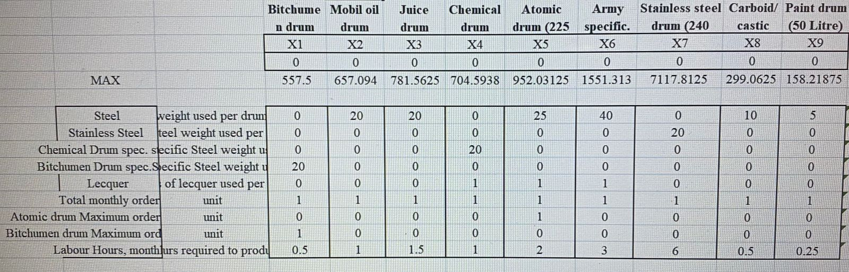
The profit is calculated beforehand by simply subtracting the cost from the selling price of each type of drum. The cost was calculated by adding up all the raw material (variable cost), labour (variable cost), and overhead costs (allocated fixed cost) for each type of drum. The data for these costs was provided by the Company. The following image shows the detail of this process.

Objective Function
The objective function maximizes the profit by multiplying all the decision variables with their respective profits and sums them up to give the total profit which is the value of Z.

Constraints

Each linear programming problem has a set of constraints or restrictions that exist with respect to the total amount of a specific resource which is required to execute the activities of the Company that would decide the final quantities that the decision variables will take. In this case, the Company face four types of constraints: raw material availability constraints, labour constraints, production capacity constraints and maximum order constraints. The Company contracts a certain amount of raw material from vendors each month and the raw material requirement for each type of drum is unique. For instance, the Bitumen drum requires 20 kgs of Bitumen drum-specific steel and no lacquer, while a Chemical drum needs 20 kgs of chemical drum-specific steel and 1 litre of lacquer. Thus, these raw material limitations must be kept in mind while devising the model as going above the Company's raw material capacity for each drum will produce an invalid solution.

Moving on, the number of labour hours that can be put towards the production process is also limited. The Company has recorded labour hours on a monthly basis, and the number of labour hours needed per drum has been computed; for example, a Mobil oil drum requires one labour hour while a Juice drum needs 1.5 labour hours. As for the production capacity constraint, this refers to the maximum total monthly order that the Company can take on considering the capacity (two available plants). This maximum capacity happens to be 22,000 drums. Lastly, as for the Bitumen drums and the Atomic drums specifically, there happens to be a maximum number that can be produced, which is dependent on the demand from their respective clients. The maximum number of Atomic drums that the Atomic energy of Pakistan demands is 750 drums a month. Similarly, the maximum number of Bitumen drums that the Attock refinery demands are 10,000 drums per month. All of these constraints must be factored in in order to ensure that our final solution remains feasible. Refer to the tables below for a summary of all of our constraints and their respective equation that we have devised.

Constraint | Explanation
Steel Constraint | The maximum stainless steel that is bought in a month due to availability limitation is 10 tonnes or 10,000 kgs.
Stainless Steel Constraint | The maximum steel that is bought in a month due to capital and availability limitations is 300 tonnes or 300,000 kgs.
Chemical Drum-Specific Steel | The maximum steel that is bought for the chemical drum (specific steel sheet used to produce this drum) in a month due to availability limitation is 50 tonnes or 50,000 kg.
Bitumen Drum Specific Steel | The maximum steel that is bought for the Bitumen drum (specific steel sheet used to produce this drum) in a month due to availability limitation is 150 tonnes or 150,000 kgs  .
Lacquer | Maximum litres of lacquer that can be bought within a month used in some drums to layer the inside - availability limitation - 1.500,000 litres
Total Monthly Order | Maximum number of drums that can be produced in a month by using two plants (inside the factory) - capital limitation - 22000 drums
Atomic Drum Max Order | The maximum number of atomic drums that can be produced and sold to the Atomic Energy of Pakistan - the sole buyer of the drum - the maximum number of drums they demand is 750 drums a month.
Bitumen Drum Max Order | The maximum number of Bitumen drums that can be produced and sold to the Attock Refinery - the sole buyer of the drum - the maximum number of drums they demand is 10,000 drums a month.
Labor Hours | The maximum number of labour hours available in a month (60 workers - working 10 hours a day, 25 days a month) is 15000 hours/month.

Constraint | Equation
Steel Constraint | 0X1 + 20X2 + 20X3 + 0X4 + 25X5 + 40X6 + 0X7 + 10X8 + 5X9 ≤ 300,000
Stainless Steel Constraint | 0X1 + 0X2 + 0X3 + 0X4 + 0X5 + 0X6 + 20X7 + 0X8 + 0X9 ≤ 10,000
Chemical Drum-Specific Steel | 0X1 + 0X2 + 0X3 + 20X4 + 0X5 + 0X6 + 0X7 + 0X8 + 0X9 ≤ 50,000
Bitumen Drum Specific Steel | 20X1 + 0X2 + 0X3 + 0X4 + 0X5 + 0X6 + 0X7 + 0X8 + 0X9 ≤ 150,000
Lacquer | 0X1 + 0X2 + 0X3 + X4 + X5 + X6 + 0X7 + 0X8 + 0X9 ≤ 1,500,000
Total Monthly Order | X1 + X2 + X3 + X4 + X5 + X6 + X7 + X8 + X9 ≤ 22,000
Atomic Drum Max Order | 0X1 + 0X2 + 0X3 + 0X4 + X5 + 0X6 + 0X7 + 0X8 + 0X9 ≤ 750
Bitumen Drum Maximum Order | X1 + 0X2 + 0X3 + 0X4 + 0X5 + 0X6 + 0X7 + 0X8 + 0X9 ≤ 10,000
Labor Hours | 0.5X1 + X2 + 1.5X3 + X4 + 2X5 + 3X6 + 6X7 + 0.5X8 + 0.25X9 ≤ 15,000

After running the solver, the optimal solution (The Maximum profit achieved) is 13279929.69, as shown in the figure below.
Objective Cell (Max)
 | Cell | Name | Original Value | Final Value
 | $Q$9 | MAX | 13279929.69 | 13279929.69
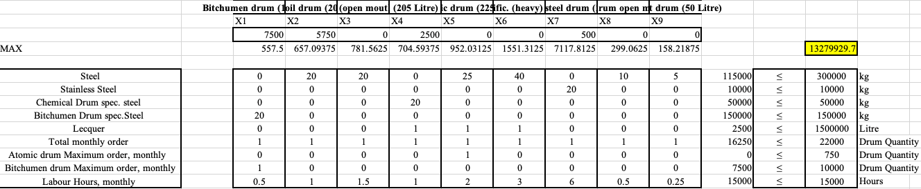

Sensitivity Analysis

Decision Variables

There are nine decision variables in the linear program, and each of the variables refers to a drum produced by Steel Drums. Below, the variable cells table of the sensitivity report is shown.

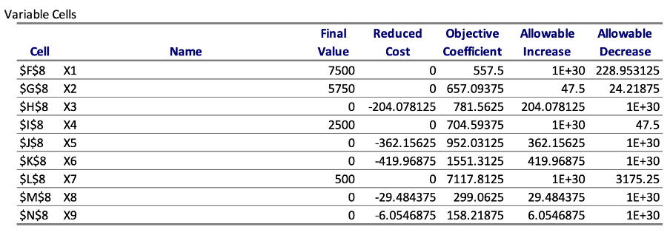
As any value in the allowable Increase and Decrease column in the variable cells table is ≠ 0 we can infer that the solution provided by the solver is not multiple optimal.

X1
The number of Bitumen drums to be produced as shown by the optimal solution is 7500. In contrast, its reduced cost equates to 0, which means that an increase in a single unit of X1 would not have any effect on the optimal solution. The profit per unit of X1 is denoted by the objective coefficient, which will remain valid; the allowable increase for the profit per unit of X1 is (+ve) infinity and a decrease of 228.953125 of profit per unit of X1. Hence the upper limit for the increase and decrease columns of 557.5 are (+ve) infinity and 328.546875.

X2
The number of Mobil oil drums to be produced, as shown by the optimal solution, is 5750. Its reduced cost equates to 0, which means that an increase in a single unit of X2 would not have any effect on the optimal solution. The profit per unit of X2 is denoted by the objective coefficient, which will remain valid till the allowable increase for the profit per unit of X2. The limits for the increase and decrease columns are 704.59375 and 533.28125.

X3
The number of Juice drums (open mouth) to be produced as shown by the optimal solution is 0. Its reduced cost equates to -204.078125 which means that an increase in a single unit of X3 would reduce the optimal solution by the reduced cost. The profit per unit of X3 is denoted by the objective coefficient, which will remain valid till the allowable increase for the profit per unit of X3. The limits for the increase and decrease columns are 985.640625 and -1E+30.

X4
The number of Chemical drums to be produced, as shown by the optimal solution, is 2500. Its reduced cost equates to 0, which means that an increase in a single unit of X4 would not have any effect on the optimal solution. The profit per unit of X4 is denoted by the objective coefficient 704.59375, which will remain valid till the allowable increase of 1E+30 and decrease of 47.5 for the profit per unit of X4. The limits for the increase and decrease columns are 1E+30 and 510.

X5
The number of Atomic drums to be produced, as shown by the optimal solution, is 0. Its reduced cost equates to -362.15625, which means that an increase in a single unit of X5 would reduce the optimal solution by the reduced cost. The profit per unit of X5 is denoted by the objective coefficient 952.03125 which will remain valid till the allowable increase of 362.15625 and decrease of 1E+30 for the profit per unit of X5. The limits for the increase and decrease columns are 1314.1875 and -1E+30.

X6
The number of Army-specific drums to be produced as shown by the optimal solution is 0. Its reduced cost equates to -419.96875, which means that an increase in a single unit of X6 would reduce the optimal solution by the value of the reduced cost. The profit per unit of X6 is denoted by the objective coefficient 1551.3125, which will remain valid till the allowable increase of 419.96875 and decrease of 1E+30 for the profit per unit of X6. The limits for the increase and decrease columns are 1971.28125 and -1E+30.

X7
The number of Stainless steel drums to be produced as shown by the optimal solution is 500. Its reduced cost equates to 0 which means that an increase in a single unit of X7 would not have any effect on the optimal solution. The profit per unit of X7 is denoted by the objective coefficient 7117.8125, which will remain valid till the allowable increase of 1E+30 and decrease of 3175.25 for the profit per unit of X7. The limits for the increase and decrease columns are 1E+30 and -2617.75.

X8
The number of Carboid/castic drums (open mouth) to be produced as shown by the optimal solution is. Its reduced cost equates to -29.484375 which means that an increase in a single unit of X8 would reduce the optimal solution by the value of the reduced cost. The profit per unit of X8 is denoted by the objective coefficient 299.0625, which will remain valid till the allowable increase is 29.484375 and decrease 1E+30 for the profit per unit of X8. The limits for the increase and decrease columns are 328.546875 and -1E+30.

X9
The number of Paint drums to be produced as shown by the optimal solution is. Its reduced cost equates to -6.0546875, which means that an increase in a single unit of X9 would reduce the optimal solution by the value of the reduced cost. The profit per unit of X9 is denoted by the objective coefficient 158.21875, which will remain valid till the allowable increase of 6.0546875 and decrease of 1E+30 for the profit per unit of X9. The limits for the increase and decrease columns are 164.2734375 and -1E+30.

Constraint Table

As any value in the allowable increase and decrease columns in the constraint table is ≠ 0, it can be inferred that the solution provided by the solver is not degenerate.
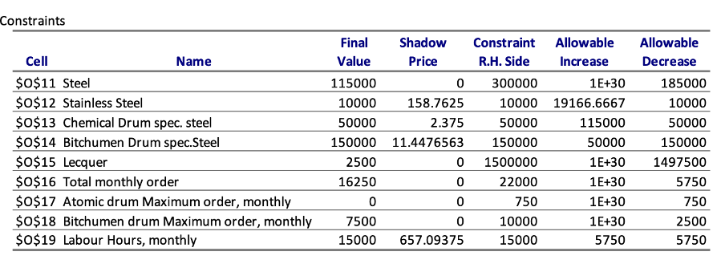
Steel
The final value of steel indicates the total amount (kg) of steel to be used in the production of the drums is 115000 kgs, which is less than the RHS value. The shadow price = 0/kg, and the quantity of steel that can be bought at the new price is infinite, while the quantity that can be reduced without affecting the optimal solution is 185,000kgs.

Stainless Steel
The final value of stainless steel indicates the total mass (kg) of stainless steel to be used in the production of the drums, which is equivalent to the RHS value and is 10000 kgs. The shadow price = 158.7625/kg which shows that to get a profit, buying an additional unit of stainless steel within the allowable increase range should be at a price of < 158.7625. The additional quantity of steel that can be bought at the new price is 19166.667kgs; the quantity that can be decreased without affecting the optimal solution is 10000kgs.

Chemical Drum-Specific Steel
The final value indicates the total mass (kg) of this specific steel to be used in the production of the chemical drums, which is equivalent to the RHS value and is 50000 kgs. The shadow price = 2.375/kg, which shows that to get a profit, buying an additional unit of this particular steel within the allowable increase range should be at a price of < 2.375, and the additional quantity of steel that can be bought is 115000kg. The quantity that can be reduced without affecting the optimal solution is 50000kg.

Bitumen Drum Specific Steel
The final value indicates the total mass (kg) of this specific steel to be used in the production of the Bitumen drums is equivalent to the RHS value and is 150000 kgs while the shadow price = 11.4476563/kg which shows, to get a profit, buying an additional unit of this particular steel within the allowable increase range should be at a price of < 11.4476563. The additional quantity of steel that can be bought is 50000kg, and the quantity that can be decreased without affecting the optimal solution is 150000kg.

Lacquer
The final value indicates the total volume (litres) of lacquer to be used in the production of the drums is less than the RHS value and is 2500 kgs while the shadow price = 0/liter indicating a profit of 0 with each additional litre of lacquer bought. An additional quantity of steel that can be bought is 50000kg, and the quantity that can be decreased without affecting the optimal solution is 150000kg.

Total Monthly Order
The right-hand value indicates the maximum number of drums that can be produced in a month by using two plants (inside the factory) - capital limitation - 22000 drums. However, the final value obtained for the optimal solution is 16250. The allowable increase is infinite, while the allowable decrease without affecting the optimal solution is 5750. The shadow price is 0 indicating that no profit is possible with each additional unit of a drum order.

Atomic drum Maximum order, monthly
The final value indicates the maximum number of atomic drums that should be produced and sold to the Atomic Energy of Pakistan, which is 0, and the maximum number of drums they demand is 750 drums a month. Without affecting the optimal solution, the increase in the atomic drums is infinite while the decrease is 750.

Bitumen drum Maximum order, monthly
This indicates the maximum order amount of Bitumen drums per month which is 10000 drums. The final value obtained is 7500 while the shadow price is 0 showing that no profit would be possible with each additional unit produced of Bitumen drums. Without affecting the optimal solution, the increase in the Bitumen drums is infinite while the decrease is 2500.

Labor Hours, Monthly
The right-hand value shows the maximum number of labour hours available in a month (60 workers - working 10 hours a day, 25 days a month) is 15000 hours/month. The final value is equivalent to the right-hand value, and the shadow price =657.09375, indicating that each additional labour hour within the allowable increase range would allow a profit as high as 657.09375. The allowable increase is equal to the allowable decrease and is 5750.

Answer Report
The objective cell shows the maximum amount of profit that Steel Drums can make by making a specific combination of drums which would allow them to stay within the constraints. The value is shown under the "final value" tab and is $13279929.69.
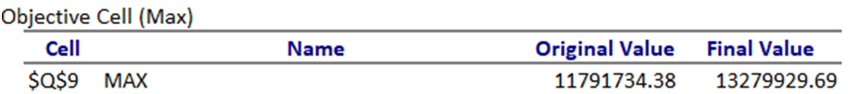

Recommendation
The variables cells show how much quantity of each decision variable should be produced to reach this maximum profit while adhering to the constraints. The solution suggests that 7500 units of X1 (Bitumen drum), 5750 units of X2 (Mobil oil drum), 2500 units of X4 (Chemical drum), and 500 units of X7 (stainless steel drum) should be produced. According to the solution, no drums of the other five kinds should be produced if the Company is looking to maximize profit. This is understandable from a profit-making point of view. However, in real life, organizations often must compromise on the maximization of profit for the sake of a more extensive portfolio, so there is a possibility that Steel Drums keeps on making at least some quantity of the other types of drums. A prime example would be that of Atomic drums, a product bought by a government organization and being in business with them could potentially have various non-monetary benefits for Steel Drums.
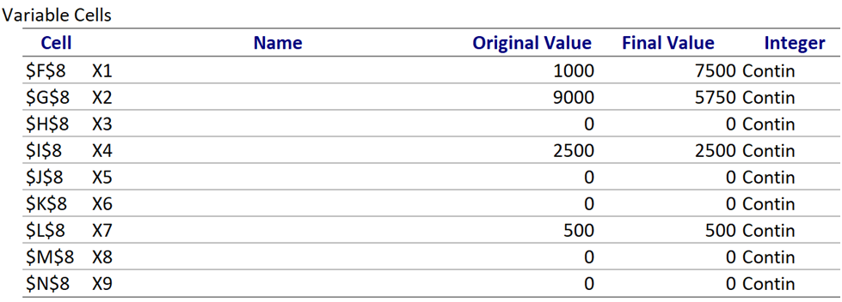
The constraints tab shows whether each variable is binding or not and the amount of slack that each non-binding variable has. Binding constraint means that the constraint is fully reached and that the left-hand side is equal to the right-hand side. The slightest increase (in case of an upper limit) or decrease (in case of a lower limit) would break the constraint so that such constraints can be seen as limiting factors for the problem. For non-binding constraints, slack shows the amount it would take for a constraint to become binding or for the right-hand side to become equal to the left-hand side. The solution is fully utilizing Stainless steel, Chemical drum-specific steel, Bitumen Drum specific steel, and the monthly labour hours, which is why these four constraints are binding. The five remaining constraints are all non-binding, and their respective slack values can be observed from the figure.
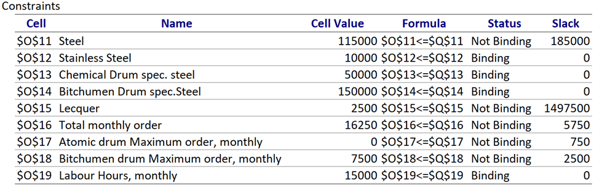

Scenario

- After the exponential surge in dollar price in Pakistan, fixed costs of making drums have also increased, decreasing the per unit profit of Carboid Drums to 250 and Chemical drums to 600. Will the solution remain optimal?

Change in profit of Carboid drums: 49.625
Change in profit of Chemical drums:104.5938
100%rule:
(49.625/inf) + (104.5938/47.5) * 100

As the answer is more significant than 100%, it can be deduced that the solution would not remain optimal.

- Steel Drums requires an answer to the question; How much will profit increase if its Monthly labour hours increase by 5000, in order to cater to a more significant order by the consumers for its drums? The cost induced for each extra labour hour per month is 600 PKR.

Current labour hours: 15000
New Labor hours: 20000
Increase: 5000
Shadow Price: 657.09375
Additional Labor hour cost: 600
The difference in shadow price and new cost: 57.0935
Allowable increase: 5750

As the additional labour hours fall within the allowable increase range presented by the solver, the report of the shadow price would remain valid. The difference between the previous and new costs is 57.0935. for the new total profit that would be generated by making this decision would be 57.0935 * 5000 = 285467.5. Hence the CEO of the Company should make this decision as this will prove profitable for the organization.

- Pakistan Atomic Energy Commission asked for 300 barrels of atomic drums at a price of 500 greater than the original. However, those 300 drums would be produced at the expense of 300 Bitumen drums.

Profit per barrel (Bitumen drum): 557.5
Reduced cost (BD):0
Allowable decrease:228.95313
Loss of not making Bitumen drums: 557.5 * 300

Profit per barrel (Atomic drum): 952.03125
Extra profit: 500
Net profit: 1452.03125
Reduced cost (AD): -362.15625
Allowable Increase: 362.15625

As the objective coefficient value of X5 (Atomic Drums) increases more than the allowable increase range, hence the solution would not remain optimal, and the order by the commission should not be accepted by steel drums.

